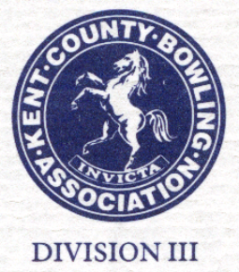
Peter Cooper
President

2018

Email: geoff.chapman11@gmail.com

County Dinner & Presentation Evening.

Application for tickets:
Details of Dinner:
Date: Saturday 20th October 2018
Time: 6.30 p.m.
Venue: Mote Park (Maidstone) Indoor Bowls Club – ME15 7RN
Meal: Four Course Meal including Wine (See choice selection below)
Cost: £25 per ticket
Music & Dancing to Clive Burnham’s “Crazy Music Disco”
Dress: Smart Casual

Please send tear off slip to Geoff Chapman, 11 Kenward Road, Maidstone, ME16 0AP with cheque payable to Kent CBA or email to above.
(Bank transfer: Sort Code 20-05-57. Account No. 10913146 – Ref: Dinner Ticket)
……………………………………………………………...................................

Name: Club / Office: Payment: Cheque / Transfer £
No. of Tickets Contact details:

Guest Names:

…………………………………………

Menu Selection:
- Prawn Cocktail / Melon / Pate’

- Roast Beef, Yorkshire Pudding, Roast Potatoes, Seasonal Vegetables

- Vegetarian option: Brie & Beetroot tart

- A selection of desserts (buffet)

- Cheese & Biscuits

- Tea / Coffee
- Dietary requirements

